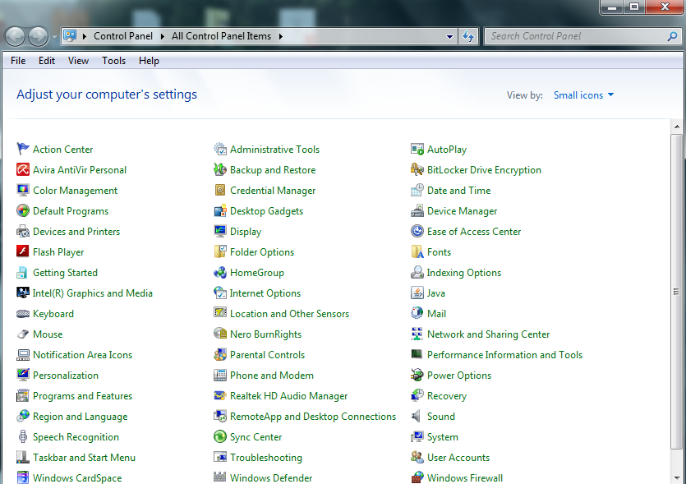

1. **SELECT ADMINISTRATION TOOLS FROM CONTROL PANEL**

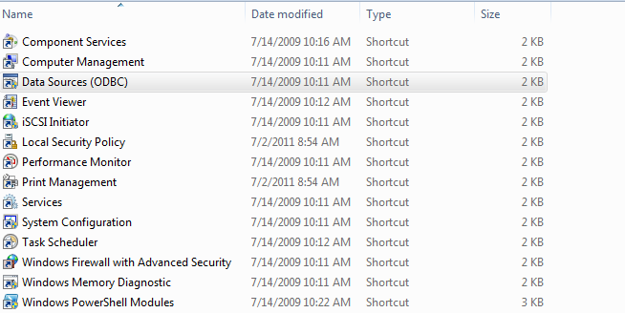

1. **SELECT DATA SOURCE (ODBC) IN ADMINISTRATIVE TOOLS ..**

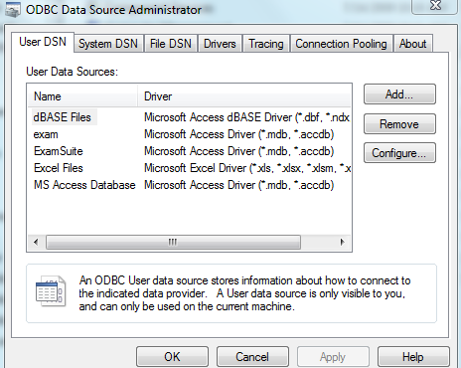

**CLICK ON ADD BUTTON TO ADD THE DATABASE**

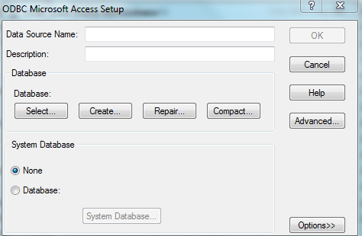

1. **CLICK ON SELECT BUTTON TO SELECT THE DATABASE**

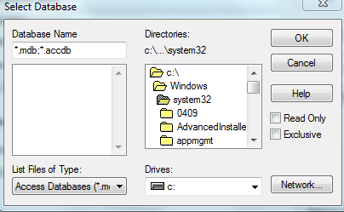

1. **GIVE THE PATH WHERE THE DATABASE HAVE BEEN STORED.**